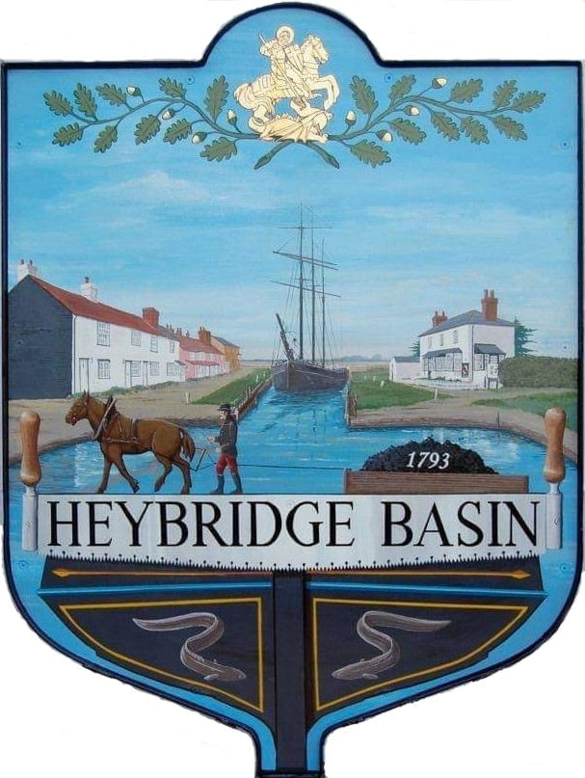

HEYBRIDGE BASIN PARISH COUNCIL

Minutes of the Extraordinary Council meeting of Heybridge Basin Parish Council held on Wednesday 3rd April 2024 at 07.00pm, at The Lock Tearoom.

PRESENT

In the Chair: M. Hodges (Chair) Absent: 0

Councillors: R. Bryson Apologies: 2 M. Hobden
G. Howat Public: 3
C. Swann

Officers: G. Lake – Clerk

It was noted that this meeting was being recorded by the Clerk.

23/222 Chair’s Welcome
Cllr Hodges welcomed everyone to the meeting.

23/223 Apologies for Absence.
Cllrs Edmond and Sjollema.

23/224 To receive Declarations of Interest in accordance with the Council’s Code of Conduct and with section 106 of the Local Government Finance Act 1992.
Cllr Hobden – Non-Pecuniary – HBSA, Basin Oars and HB River care and Cllr Howat – Non-Pecuniary - HBCSA

23/225 Planning Applications
- To consider any planning applications received after the publication of the agenda and to agree the action to be taken.

24/00215/TCA– Two Ways, Lock Hill – T1 Silver Birch, height reduction by 5m, T2 Bay, coppice, T3 Crab apple, pruned back by 0.5m
It was resolved that the Council would recommend the granting of planning permission for this application.

24/00183/FUL – Leanna House, Lock Hill – Part demolition existing workshop; two storey side extension, raising of roof and conversion to residential dwelling with ground floor garage below.
It was resolved that the Council would recommend the granting of planning permission for this application in principle subject to better clarification on external detailing.

23/226 Daisy Meadow Car Park (DMCP)
  - To ratify the decision made regarding principal designer and agree any action to be taken.
On 25th March 2024, the Clerk was notified that under CDM (2015 Regulations) a Principal Designer was required and needed to be appointed prior to the works commencing. Camway advised that they were able to provide this at an additional cost of £1,600.00 + VAT.
The Clerk contacted EALC for advice and was advised that due to insufficient time to call a meeting before 2nd April 2024 that Councillors were able to agree the additional cost via e-mail communication and be ratified at the next appropriate meeting.

All members resolved to accept the additional cost from Camway to provide a Principal Designer.

23/227 Pursuant to section 1(2) of the Public Bodies (Admission to Meetings) Act 1960 it is resolved that, in view of the confidential nature of the business about to be transacted, it is advisable in the public interest that the press and the public be excluded, and they are instructed to withdraw.

Members of the public left.

23/228 DMCP
- To consider the correspondence received regarding the access road works and agree any action to be taken.
Correspondence was noted and responses were agreed.

23/229 Timber Yard
  - To discuss the email received from Govey Homes Ltd and agree any action to be taken.
It was resolved to invite Govey Homes Ltd to a meeting.

There being no further business the meeting closed at 08:08pm
Provisional Date of the next Council Meeting Tuesday 23rd April 2024

Clerk Contact details: clerk@heybridgebasinpc.org.uk
Website: www.heybridgebasin-pc.gov.uk

